**Question/Answer Booklet**

**Name:**

**PHYSICAL EDUCATION STUDIES YEAR 11 ATAR**

**Semester 1 Exam 2021**

**Time allowed for this paper**

Reading time before commencing work: 0 minutes

Working time for paper: 2 Hours

***To be provided by the candidate***

Standard items: pens (blue and black), pencils, eraser, correction fluid, ruler, highlighter

**Important note to candidates**

No other items may be taken into the examination room. It is **your** responsibility to ensure that you do not have any unauthorised notes or other items of a non-personal nature in the examination room. If you have any unauthorised material with you, hand it to the supervisor **before** reading any further.

**Structure of paper:**

|  |  |  |  |
| --- | --- | --- | --- |
| Section | Number of questions available | Number of questions to be attempted | Marks available |
| **Section One:**  Multiple-Choice | 20 | 20 | 20 |
| **Section Two:**  Short Answer | 17 | 17 | 70 |
| **Section Three:**  Extended Answer | 3 | 2 | 20 |
|  |  |  | **110** |

Answer the twenty **(20)** Multiple-Choice questions on the separate Multiple-Choice answer sheet provided.

**Multiple Choice (20 marks)**

1. Which one of the following statements is **true** of the bloods pathway?
2. Blood enters the Right Ventricle, then flows to the Right Atrium, before traveling into the Pulmonary Vein and returns to the heart via the Pulmonary Artery.
3. Blood enters the Left Atrium, then flows to the Left Ventricle, before traveling into the Pulmonary Artery and returns to the heart via the Pulmonary Vein.
4. Blood enters the Right Atrium, then flows to the Right Ventricle, before traveling into the Pulmonary Artery and returns to the heart via the Pulmonary Vein.

(d) Blood enters the Right Atrium, then flows to the Right Ventricle, before traveling into the Pulmonary Vein and returns to the heart via the Pulmonary Artery.

1. An Anterior Cruciate Ligament (ACL) knee injury is one of the most devastating injuries that an elite AFL footballer can sustain. The ACL connects which two structures?

(a) Tibia to the Hamstring Muscle.

(b) Tibia to the Femur.

(c) Tibia to the Meniscus Cartilage.

(d) Tibia to the Hamstring Tendon.

1. Controlled breathing techniques are often used by athletes as a relaxation technique. When an athlete breathes out:

(a) the diaphragm relaxes and the intercostal muscles relax.

(b) the diaphragm relaxes and the intercostal muscles contract.

(c) the diaphragm contracts and the intercostal muscles contract.

(d) the volume of the lungs increases.

4. Where is the heart located in relation to the sternum?

1. Superior
2. Inferior
3. Anterior
4. Posterior
5. In water polo, goal keepers defend by elevating their arms above their head. Which superficial muscle of the back contracts to elevate the scapula and produce the defensive position shown in the image below?

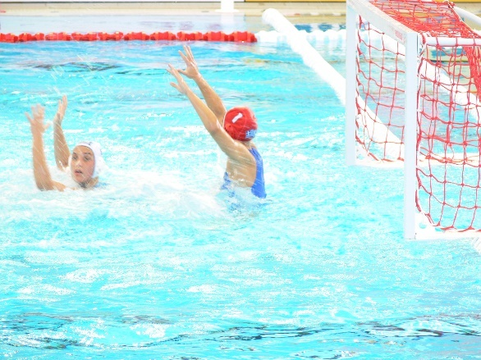

(a) Trapezius

(b) Triceps

(c) Deltoid

(d) Latissimus Dorsi

6. In the action of spiking a volleyball, the velocity of the ball will depend on the total force applied. The force applied will depend upon:

(a) the power of the smallest muscle groups.

(b) the power of the largest muscle groups.

(c) the velocity of the last body part.

(d) the velocity of the first body part.

1. The type of motion that a sprinter exhibits in running a 100m sprint would best be

described as:

(a) general motion.

(b) linear motion.

(c) angular motion.

(d) projectile motion.

1. Which of the following is **not** an example of Newton’s first law of motion in cricket?
   1. the bat contacting the ball.
   2. the ball hitting the boundary fence and changing direction.
   3. the ball stopping immediately when caught by a player.
   4. the speed of the cricket bat directly prior to impact with the ball.
2. In the sport of lacrosse, players are required to be agile and well balanced. A player is demonstrating dynamic balance when:

(a) they are moving towards their centre of gravity.

(b) their centre of gravity is within the body.

(c) their line of gravity is within their base of support.

(d) they are stationary.

1. Submaximal force is required during some sporting situations to produce optimal performance. Which of the following is the best example of submaximal force application?

(a) pushing of the blocks in a swimming dive start.

(b) hitting a drop shot in badminton.

(c) griping a tennis racket in preparation for an overhead smash shot.

(d) execution of a well-timed high jump.

1. Performing a triple jump can be classified as a:

(a) Discrete motor skill.

(b) Continuous motor skill.

(c) Serial motor skill.

(d) Motor skill.

1. At half-time in an Inter-School touch rugby game, a coach speaks to her players about the need to be more accountable in defending their try line, by maintaining communication and evenly positioning themselves across the field. This is an example of:

(a) intrinsic feedback.

(b) concurrent feedback.

(c) constructive feedback.

(d) terminal feedback.

13. A surfer is warming up on the beach practising the movement of ‘popping-up’ onto the board. Which type of cues is she relying on to improve her body position?

(a) visual

(b) proprioceptive

(c) verbal

(d) balance

1. The beam is renowned as the ultimate test of nerves for female gymnasts, unforgiving in exposing any lack of focus or preparation. The national coach of a gymnast knows that her athlete performs best when she focuses on her technique and not the score required to make the final in this apparatus. Based on this information, which of the following types of feedback should the coach provide?

(a) knowledge of performance.

(b) intrinsic feedback.

(c) knowledge of result.

(d) terminal feedback.

15. A kayaker is paddling down a series of rapids on the Avon River and notices reduced water flow in one section due to a submerged tree log. The kayaker realises it will be too difficult for the kayak’s hull to clear this section, so does not attempt to navigate the hazard. According to the information-processing model, what stage of the model did the kayaker reach?

(a) identification of stimuli/input.

(b) response identification/decision-making.

(c) response/output.

(d) feedback

16. Feedback about the outcome of a performance such as seeing your time for a 100-metre running sprint is known as:

(a) knowledge of outcome.

(b) knowledge of performance.

(c) knowledge of results.

(d) knowledge of success.

17. In which of the following examples is Newton’s third law most evident?

(a) Rowing a boat.

(b) Performing a handstand.

(c) Applying spin to a soccer ball.

(d) Giving with the ball when catching a cricket ball.

18. The mechanism responsible for increased blood flow to the working muscles is:

(a) vasoconstriction

(b) vasodilation

(c) the muscle pump.

(d) reduced cardiac output.

19. When a learner decides on or develops a motor program based on information input, they are likely to be in which stage of the information processing model?

(a) Identification of stimuli/input.

(b) Response identification/decision making.

(c) Response/output.

(d) Feedback

20. A softball player has two bats, one of which is 300 grams heavier than the other. If the player swings both bats at the same velocity, the heavier bat will be able to produce greater ________ than the lighter bat.

(a) acceleration

(b) momentum

(c) force

(d) torque

**Short Answer (70 marks)**

This section has **Seventeen (17** **questions**). Answer **all** questions. Write your answers in the spaces provided in this Question/Answer Booklet. Wherever possible, confine your answers to the line spaces provided. Use a blue or black pen (**not** pencil) for this section.

**Question 21 (6 marks)**

The following question relates to the image below of the footballer performing a defensive slide tackle.

.

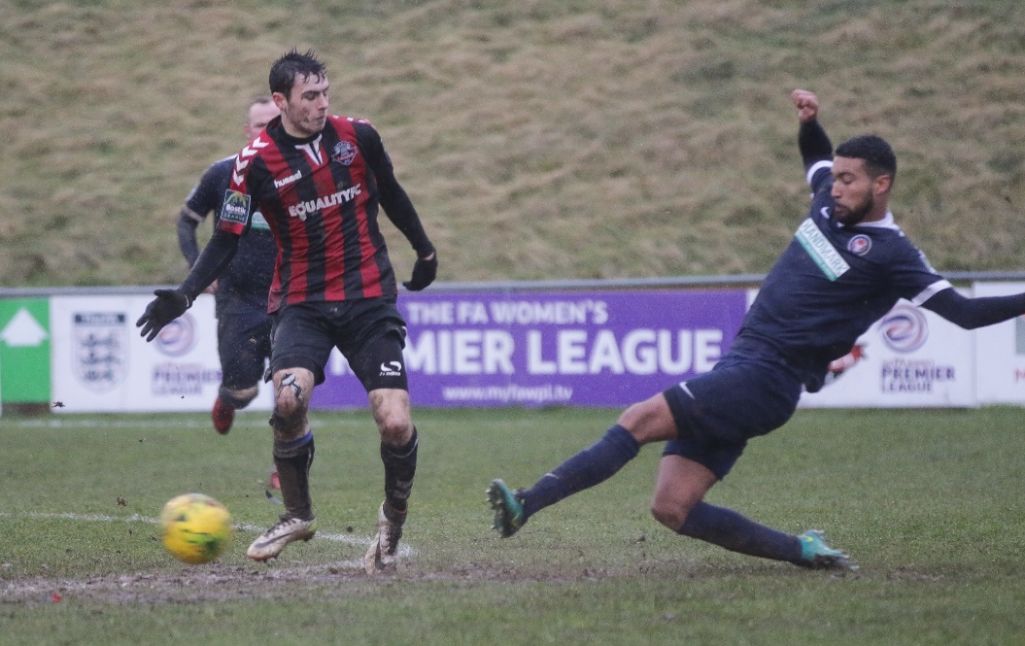

1. Identify the articulating bones of the hip joint. (2 marks)

1. Identify the movement of the defending players’ left knee and ankle which is attempting to intercept the ball in the tackle. (2 marks)

1. Identify the agonist muscles responsible for the movement in the defending players’ left knee and ankle. (2 marks)

**Question 22 (5 marks)**

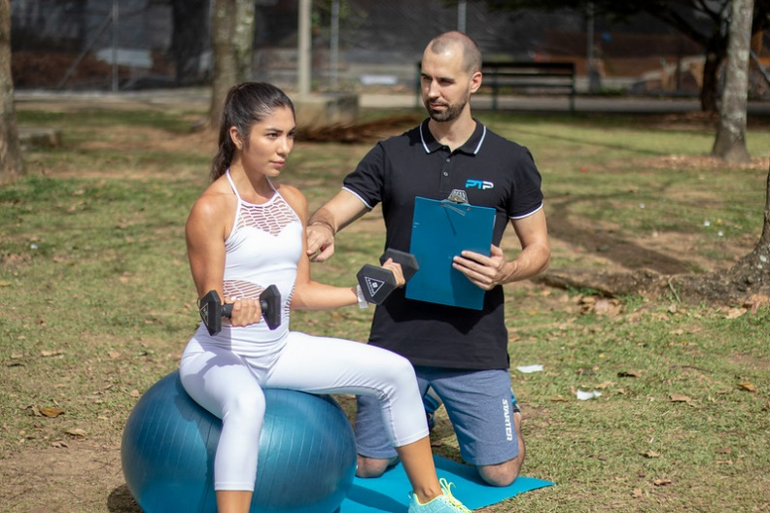

* + 1. The personal trainer, pictured above, is advising his client about the importance of controlling the contraction of the Dumbbell curl. Explain how the muscles of the upper arm form a partnership that allows coordinated movement.

(2 marks)

1. Briefly outline the function of the arteries, veins and capillaries in the circulatory system.

(3 marks)

**Question 23 (5 marks)**

The wearing of face masks to prevent the transfer of COVID-19 has been mandatory amongst spectators and officials around sporting fixtures around the world. The World Health Organisation (WHO) does not recommend wearing a facial mask during exercise because it can make breathing more difficult and potentially a feeling of “light-headedness” when exercising during exertion. Explain the mechanics of breathing during inhalation and how wearing a facial mask during exercise could affect the concentration of gases entering the alveoli of the lungs.

______________________________________________________________________

**Question 24 (5 marks)**

Identify the anatomical features within the right lung in the diagram below.

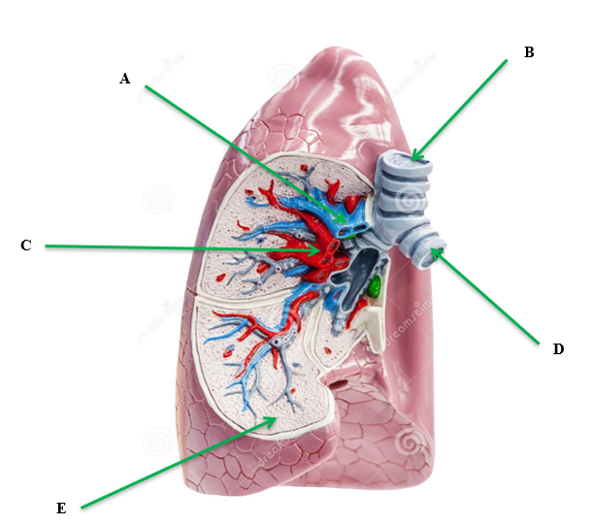

|  |
| --- |
|  |
|  |
|  |
|  |
| E. |

**Question 25 (3 marks)**

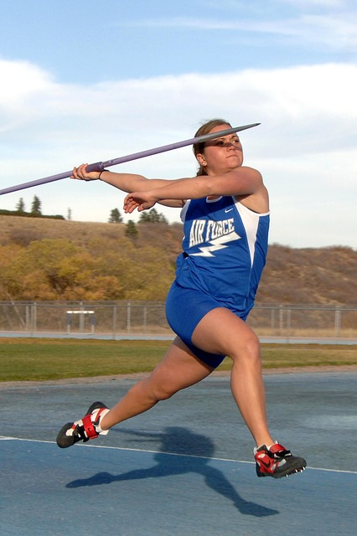

When trying to throw a javelin for distance, athletes need to coordinate the linear motion of the throwing arm to create linear velocity.

(a) Describe the **two (2)** factors the athlete can increase to maximise the amount of linear velocity transferred to the javelin. (2 marks)

(b) Give one example of how an athlete can modify their technique to maximise linear velocity.

(1 mark)

______

**Question 26 (2 marks)**

Sporting commentators often use the words “speed” and “acceleration” to describe an object or athlete’s movement in competition. Describe the difference between speed and acceleration?

**Question 27 (3 marks)**

Athletes receive multiple cues from their coaches in the efforts to improve performance. Identify **three (3)** different types of cues used by coaches, **providing an example** of how each cue could be used to assist in learning a new skill?

**Question 28 (6 marks)**

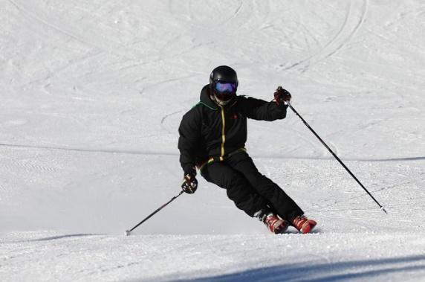

Skiing is a popular recreational activity as well as a competitive sport. Classify skiing according to the following criteria. Clearly indicate on the continuum and justify your response for each.

(a) Muscle involvement (2 marks)

Fine Gross

* 1. Environment (2 marks)

Closed Open

(c) Continuity (2 marks)

Discrete Serial Continuous

**Question 29 (3 marks)**

Passing is a fundamental skill of netball. A successful shoulder pass often requires a player to throw the netball with high velocity. Explain how the use of sequential movement can achieve maximal speed in a successful shoulder pass.

**Question 30 (3 marks)**

Golf players use a variety of different clubs to ensure the golf ball travels the required distance. The angle on the club face affects the flight path and trajectory of the golf ball in the air. On the graph below, draw and label the three main trajectories a golf ball could make in its flight path in the air.

**Height**

**Distance**

**Question 31 (2 marks)**

To achieve maximum horizontal distance, a projectile should be released at a 45⁰ angle. Other than shot put, explain one sporting example where it is necessary to have an angle greater than 45⁰, and one example where it is necessary to have an angle less than 45⁰.

**Question 32 (6 marks)**

Using specific examples, identify **three (3)** types of motion in the picture below.

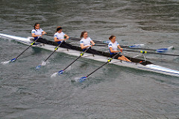

**Question 33 (3 marks)**

Define the terms positive, negative and zero acceleration and provide an example of each during a 200-metre freestyle swim.

**Question 34 (4 marks)**

Using examples, explain **two (2)** types of balance a gymnast may display during a floor routine.

**Question 35 (4 marks)**

Cyclists in the Tour de France cycling race compete in teams and have support vehicles which provide nutrition, technical equipment and coaching support. Information on the race is also communicated via in-ear radio which provides feedback aiding in the potential success of the cycling team. Explain **two (2)** purposes of providing feedback to cyclists in such a race as the Tour de France.

**Question 36 (4 marks)**

Identify the **bones** on the diagram below. Answer in the space provided.

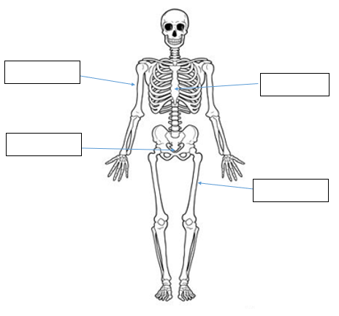

**Question 37 (4 marks)**

Western Australia’s Jackson Symonds of Sorrento SLSC claimed a record fifth Open Beach Sprint title at the 2019 National Surf Lifesaving Championships. Successfully winning sprint running races requires a fast start. Using your understanding of the information-processing model, explain how Jackson would successfully get a way to an explosive start in the sprint.

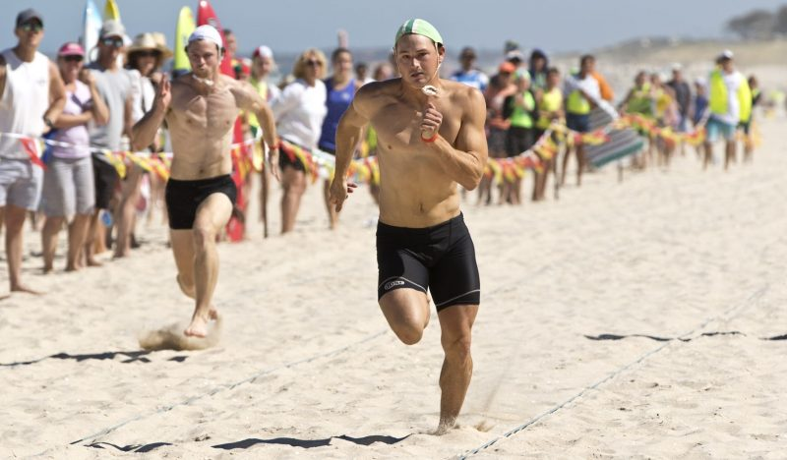

**Extended Answer (20 marks)**

This section contains three (3) questions. **You must answer two (2) of these questions.** Write your answer in the spaces provided.

Spare pages are included at the end of this booklet. They can be used for planning your responses and/or additional space if required to continue an answer.

* Planning: if you use the spare pages for planning, indicate this clearly at the top of the page.
* Continuing an answer: If you need to use the space to continue an answer, indicate in the original space where the answer is continued, i.e. give the page number. Fill in the number of the question that you are continuing to answer at the top of the page.

**Question 38 (10 marks)**

Australian Cameron Smith came second at the 2020 US Masters and became the first player in the tournament’s history to shoot four consecutive rounds in the sixties. Smith ended up 15 under par having shot scores 67, 68, 69 and 69. His consistency came from good technique and the successful use of several biomechanical principles in putting, approach shots and driving the ball off the tee. Discuss the application of various golf shots in relation to the following biomechanical principles:

* Optimal Projection
* Segmental Interaction
* Balance

**Question 39 (10 marks)**

1. Using the three (3) athletes pictured below, discuss how the muscle fibre types

would vary for each athlete. In your answer, state each muscle fibre, include the

muscle fibre ratio of each.

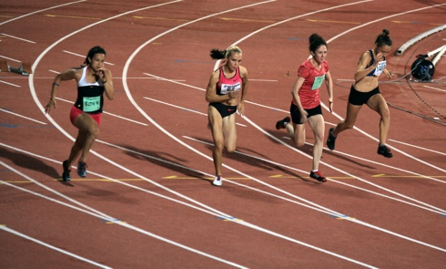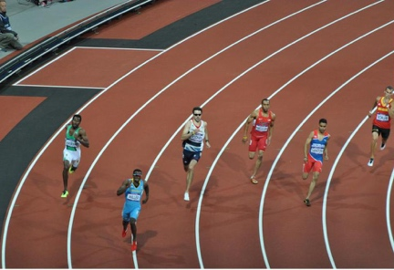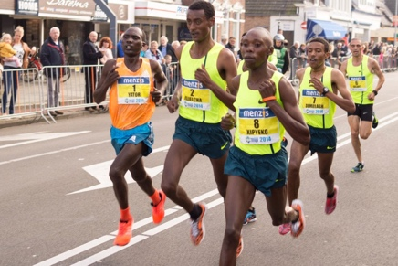

400m sprinter

Marathon runner

100m sprinter

(3 marks)

(b) Discuss how each of Newton’s three (3) Laws relate to the 100m sprint.

(7 marks)

**Question 40 (10 marks)**

The three golfers pictured below are in different phases of their golf career. The child pictured on the left is attempting to hit a golf ball for the first time, the recreational golfer pictured in the middle is working to improve his game, while the adult pictured to the right is playing in a professional tournament.

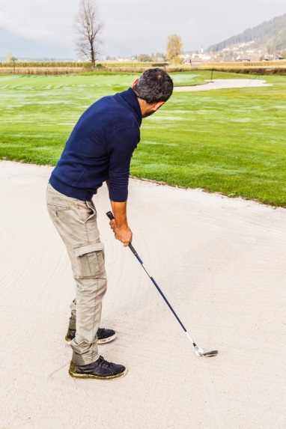

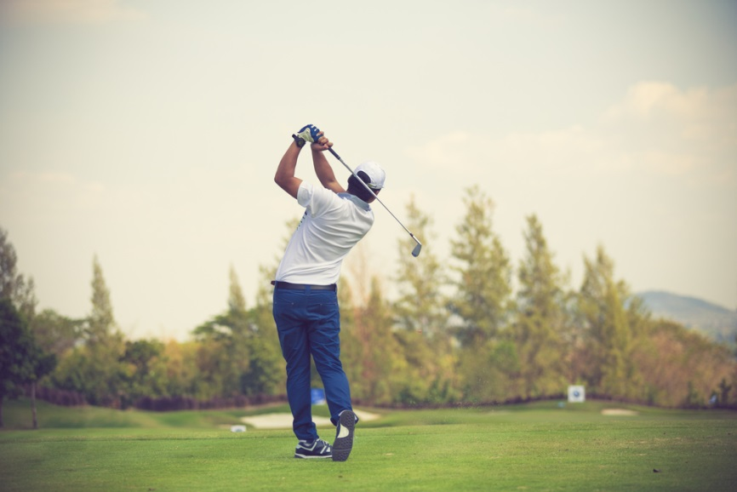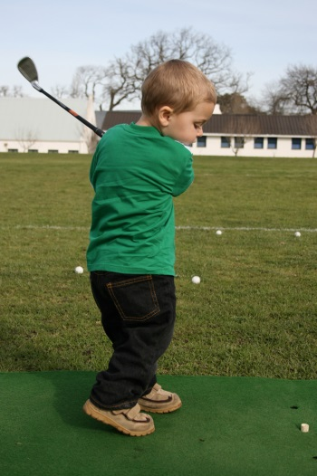

According to the Fitts and Posner model of skill learning, explain the three phases a golfer would move through as they progress from beginner level through to professional. In your response, identify the performance characteristics and type of feedback the learner would require in each phase to maximise their skill learning. Also identify the phase you would expect the golfer to spend the shortest amount of time in.

**End of paper**

**Additional Working Pages**

______________________________________________________________________